MSIS 638

Jia Liang Ma

Final Exam

### Purpose: showing competence in analyzing a real-world decision-making situation using sophisticated mathematical models

You have *72 hours* to apply the proper mathematical models (linear programming, payoff table, regression analysis) to solve the following problem and answer the corresponding questions.

**Problem**

RevolutionX is a startup tech company in robotics. The management is considering three different configurations for their new model, RobX. The three configurations are **Prime**, **Limited**, and **Ultimate**. The data for each of the configurations (per unit) is given in the following table. RevolutionX needs to find the optimal production of each of the configurations to maximize total profit.

|  |  |  |  |  |
| --- | --- | --- | --- | --- |
| **Configuration** | **Profit ($)** | **Funding Needed ($)** | **Assembly (hrs.)** | **Material (units)** |
| **Prime** | 1500 | 4500 | 45 | 32 |
| **Limited** | 2100 | 5300 | 61 | 41 |
| **Ultimate** | 3200 | 7100 | 83 | 63 |

Based on the marketing data the production of the Ultimate configuration cannot exceed the production of Prime and Limited configurations combined. (U ≤ P + L), (Non-negativity) Furthermore, the production of Prime and Limited configurations must be equal. (Constraints A)

The available funding could be **1**, **2**, **3**, or **4** million dollars with the corresponding probabilities $p_{1},p_{2},p_{3}$ and $p_{4}$. The chance of having 1 or 2 or 3 million dollars funding are equal (i.e., $p_{1}=p_{2}=p_{3}$). The chance of having 4 million dollars funding is double the chance of having 1 million dollars funding (i.e., $p_{4}=2p_{1}$). (The total of $p_{1},p_{2},p_{3}$, $p_{4}$ are 1), (Constraints B)

Currently they are considering three potential locations for their new factory that would be used to produce the new model. The three alternatives are: **Boston**, **Chicago**, and **Huston**. They need to choose **one** of these locations. The available Assembly hours and Material units depend on the location of the factory according to the following table:

|  |  |  |
| --- | --- | --- |
| **Location** | **Assembly (hrs.)** | **Material (units)** |
| **Boston** | 35000 | 15000 |
| **Chicago** | 30000 | 20000 |
| **Huston** | 25000 | 25000 |

A final constraint is that the production of the three configurations combined must be at least equal to the expected demand for the next month (i.e., May in the following table), that should be estimated using the following demand data for the past year. (Constraints C)

|  |  |  |  |  |  |  |  |  |  |  |  |  |  |
| --- | --- | --- | --- | --- | --- | --- | --- | --- | --- | --- | --- | --- | --- |
| Apr | May | June | July | Aug | Sept | Oct | Nov | Dec | Jan | Feb | Mar | Apr | May |
| 3850 | 78 | 89 | 82 | 112 | 106 | 131 | 125 | 145 | 173 | 182 | 169 | 195 | ??? |

You need to answer the following questions based on quantitative analysis. You need to use Regression Analysis, Linear Programming, and Payoff Table Analysis to answer the following questions.

**Question 1:** What is the expected demand for May? If you get a fractional value for the May demand, you need to round it up or down and *justify why you decided to round it up or down*.

The expected demand for May is around 203. The reasons I would like to round it down are because the demand of goods can not be fractional value, they must be the entire products for sale. Also, in this case, the forecast number of demands is 203.233, based on the materials and assembly time are limited. It is important to maximize the profit for production. So, I think round it down would be better than round it up.

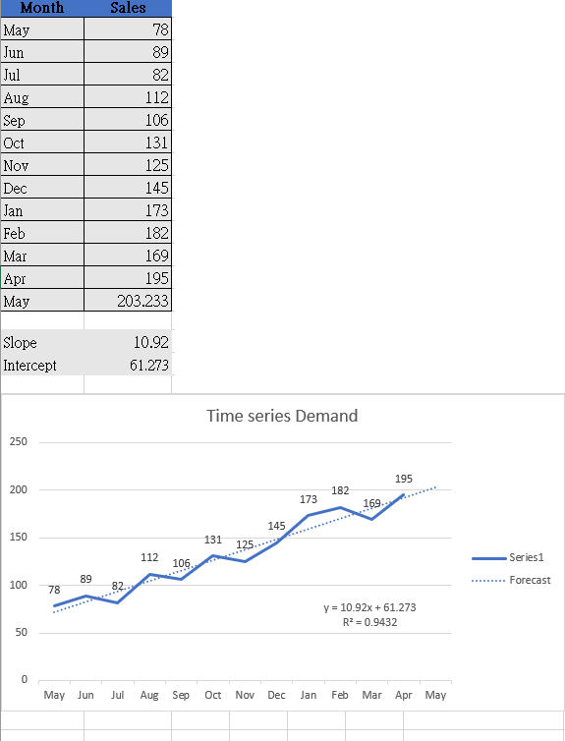

**Question 2:** Is the relationship between the month and demand strong? You need to answer this question using the appropriate quantitative measure from your model.

After deleting the outlier, it will make the analysis more accurate. The R-square in this case is 0.9432. In simple linear regression, with a higher R-square means higher correlation. Yet, in the data consists of time series data (monthly), it is usually a bad sign rather than a good one. Because there will often occur some time patterns in the errors.

However, the regression model shows the nearly output in R-square and Adjusted R-square. With the evidence that regression line fitted the demand line as well. In my view, I think the relationship between the month and demand is strong.

**Question 3:** Create the payoff table using the three locations as alternatives and the four available funding possibilities as scenarios. You need to calculate the payoff corresponding to each combination of location and funding scenario.

Payoff Table of location and funding scenario

***Boston 1/ 2/ 3/ 4 million funding:***

Max 1500P + 2100L + 3200U

Funding ($): 4500P + 5300L + 7100U ≤ 1000000/ 2000000/ 3000000/ 4000000

Assembly(hrs.): 45P + 61L + 83U ≤ 35000

Material (units): 32P + 41L + 63U ≤ 15000

U ≤ P + L

P = L

P + L + U ≥ 203

***Chicago 1/ 2/ 3/ 4 million funding:***

Max 1500P + 2100L + 3200U

Funding ($): 4500P + 5300L + 7100U ≤ 1000000/ 2000000/ 3000000/ 4000000

Assembly(hrs.): 45P + 61L + 83U ≤ 30000

Material (units): 32P + 41L + 63U ≤ 20000

U ≤ P + L

P = L

P + L + U ≥ 203

***Huston 1/ 2/ 3/ 4 million funding:***

Max 1500P + 2100L + 3200U

Funding ($): 4500P + 5300L + 7100U ≤ 1000000/ 2000000/ 3000000/ 4000000

Assembly(hrs.): 45P + 61L + 83U ≤ 25000

Material (units): 32P + 41L + 63U ≤ 25000

U ≤ P + L

P = L

P + L + U ≥ 203

***Payoff Table***

|  |  |  |  |  |
| --- | --- | --- | --- | --- |
| **Location** | **1M Funding** | **2M Funding** | **3M Funding** | **4M Funding** |
| **Boston** | 3687773 | 753769 | 753769 | 753769 |
| **Chicago** | 3687773 | 833333 | 1005025 | 1005025 |
| **Huston** | 3687773 | 833333 | 919118 | 919118 |

**Question 4:** What are the probabilities for funding scenarios (i.e., $p_{1},p_{2},p_{3},p_{4}$)? You need to show your calculation.

$p_{1}$ = $p_{2}$ = $p_{3}$

$p_{4}$ =2

+ ++=1

So, 5 $p_{1}$ =1; $p_{1}$ =0.2 thus $p_{2}$ = $p_{3}$ =0.2; $p_{4}$ = 2 $p_{1}$ =0.4

**Question 5:** What location should RevolutionX choose based on the expected profit for each location?

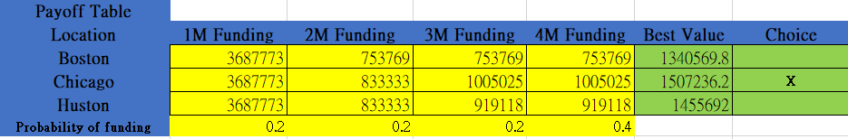

As the figure shown above, we can see Chicago has the highest best expected value (1507236.2) for producing RevolutionX.

**Question 6:** What is the corresponding EVPI?

EVPI (Maximum payment for additional information)

EVPI= EPPI - Best expected value

= 3687773*0.2+833333*0.2+1005025*0.2+1005025*0.4 -1507236.2 = 1507236.2 - 1507236.2 = 0

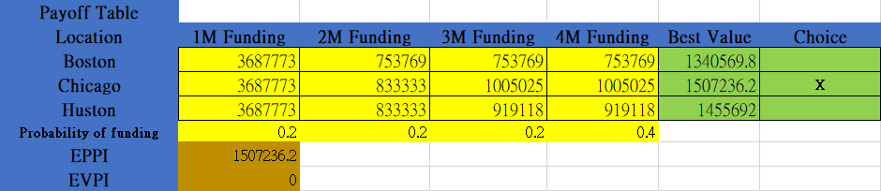

**Question 7:** Justify the value of EVPI. You need to provide a valid argument why EVPI has this particular value.

For the expected value of perfect information (EVPI), in this case, the value we are looking for is based on geography location and the expected profit with funding probabilities.

For example, we can calculate the value of EVPI in Boston and Huston to verify the particular value of EVPI

Boston: 1507236.2 - 1340569.8 = 166666.4

Huston: 1507236.2 - 1455692 = 51544.2

As the residuals shown, they will be some value for EVPI if RevolutionX chose Boston or Huston rather than Chicago as production location.

However, the EVM in Chicago is the same as EPPI, so the value for EVPI is 0.

**Question 8:** What is the most important parameter(s) of the model to conduct sensitivity analysis on? You need to provide reasoning why you chose that parameter(s). Conduct sensitivity analysis on the parameter you believe is the most important one.

In this case, I think the most important parameter is demand parameter. For other variables and constraints, changing them the results might stay the same. However, when it comes to the demand constraints, slightly changing the value, the results of profit and units will change tremendously. In this way, we should conduct the sensitivity analysis on the demand constraint.

Take 150 and 300 as changing value, the original value is 203. After conducting the sensitivity analysis, we can see that the results changed drastically in the units into 150 and 300 with the different demand for May.

***Note:*** *You need to submit ONE WORD file and ONE EXCEL file. You need to answer ALL of the above questions in the WORD DOCUMENT based on your calculations in the EXCEL file.*

***Note:*** *In order to have a fair exam, NO QUESTION WILL BE ANSWERED DURING THE EXAM.*

***Note:*** *This is an individual exam. You are not allowed to share or discuss your work with anyone except the professor or TA during, or after the exam.* ***Any similarity between the submitted reports will be investigated and followed up and might result in FAILING the course.***